Growl for Windows
Display SDK

Table of Contents

- Overview
- Getting Started
- Non-Visual Displays
- Visual Displays
  - Handling multiple on-screen notifications
  - Notification window characteristics
  - Handling Images
  - Resizing Windows to Fit Contents
  - Animation Effects
- Display Settings
  - Settings Panel
  - Loading and Saving Settings
- Deployment
- Important Notes

Overview

Growl for Windows provides a plug-in architecture that allows developers to create custom displays for handling notifications. Although called ‘displays’, the handlers can be either visual or non-visual (such as logging to a file, sending an email, etc).

Getting Started

Growl displays are implemented as .NET assemblies. Although the display base libraries are written in C#, you can create your displays in any .NET-compliant language, including C#, VB.NET, and VC++.NET.

If you are using Visual Studio, create a new Class Library project. There are two assemblies that need to be referenced in order to create a custom display:

- Growl.CoreLibrary.dll
- Growl.DisplayStyle.dll

Add references to both of these assemblies in your project. The next few steps will depend on if you are developing a visual or non-visual display.

Non-Visual Displays

Non-visual displays handle notifications but do not show a visible alert on the screen. Examples of non-visual display behaviors include:

- Forwarding notifications to an email account
- Sending notification information to a batch file or another application
- Writing data to a log file
- Posting to a web API (blog, Twitter, RSS, etc)

If you are creating a non-visual display, you should create a new class that inherits from Growl.DisplayStyle.Display.

public class SampleDisplay : Display

This base class provides most of the functionality required to interact with the Growl client. You will need to provide some specific information such as the display’s name, description, author, website, and version. Since non-visual notifications are by definition not visible, they don’t have to worry about handling click or close requests. The only method you need to implement is the HandleNotification method.

See the ‘Sample Display’ project in the Growl Display SDK for a working example.

Visual Displays

Visual displays show an on-screen message when a notification is received. The most important criteria is that the notifications should be unobtrusive. Specifically, they:

- Should not steal the focus from the current active window
- Should not be modal
- Should not require user interaction to operate properly
- Should automatically dismiss themselves if the user does not interact with them after a set amount of time.
- Should respect user preferences such as Stickiness and Priority

To create a visual display, your display should inherit from Growl.DisplayStyle.VisualDisplay:

public class SampleVisualDisplay : VisualDisplay

Additionally, you should create a form that inherits from Growl.DisplayStyle.NotificationWindow. This will be the actual display window that is shown to the user.

public partial class SampleVisualWindow : NotificationWindow

In your display class’ HandleNotification method, you should perform the following steps:

- Create a new instance of your notification window
- Call the notification window’s .SetNotification() method. This passes the actual notification data to the notification window.
- Set any other custom properties of your notification window
- Call the display’s .Show(NotificationWindow) method. You should always call this method rather than the notification window’s .Show() method directly since it handles hooking up the events necessary for handling callbacks and layout management.

public override void HandleNotification(Notification notification, string displayName)
{
SampleVisualWindow win = new SampleVisualWindow();
win.SetNotification(notification);
win.BackColor = GetColorFromSetting(SETTING_BGCOLOR, BGCOLOR);
this.Show(win);
}

The base VisualDisplay class will handle most of the rest of the logic for handling the notification window.

Handling multiple on-screen notifications

The only other method you may want to override in your display class is the GetLayoutManager() method. If you create a class-scoped instance of the Growl.DisplayStyle.LayoutManger class and return it from the GetLayoutManager() method, the display will automatically handle repositioning any exisiting on-screen notifications when a new notification is shown or closed. The LayoutManager can be configured to control the direction and spacing between multiple notifications. If you don’t want to take advantage of the built-in layout management behaviors, you can elect not to override GetLayoutManager or simply return null.

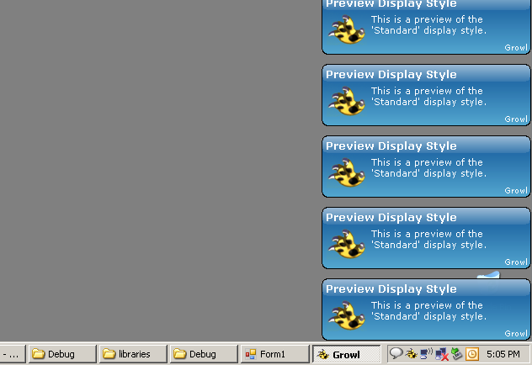

Notification Window Characteristics

The actual look and behavior of the notifications are defined in the notification window class you created. With few exceptions, you can perform any of the same operations you can perform in normal WinForms. Two properties to note are the .TopMost and .ShowInTaskbar – both are set to the proper defaults in the base NotificationWindow class and should not be modified. Other important methods include:

AfterLoad event:
Any initial window sizing or positioning should be done in the AfterLoad event. By doing it here, it is late enough to prevent most focus-stealing issues (see Important Notes below), but early enough to allow proper operation of animators and layout managers.

HookupClickEvents method:
By calling the HookUpClickEvents method, the form will automatically hook up the Click event of any child controls on the form to fire the NotificationClicked event. If you do not call this method, you must make sure to propogate any click events on child controls up to the parent form. It is almost always preferred to call this method and let the base class handle the logic for you.

AutoClose method:
If you want your notification to automatically close after a set amount of time, call the AutoClose property in your constructor to set the duration. The auto-close behavior will automatically trigger any associated Animator to peform any closing animation. Setting the .Sticky property of the notification will override the auto-close behavior in the default implementation. It is almost always preferred to call this method and let the base class handle the logic for you.

public SampleVisualWindow()
{
InitializeComponent();

// perform any initial sizing/positioning here this.AfterLoad += new EventHandler(SampleVisualWindow_AfterLoad);

// fade the notification in/out
this.Animator = new FadeAnimator(this);

// automatically handle click events HookUpClickEvents(this);

// automatically fade out after 4 seconds this.AutoClose(4000);
}

Resizing Notifications to Fit Contents

Notification data such as Title, Description, ApplicationName, and others can be of an unlimited length. As such, it is important to make sure your notification window can gracefully handle displaying the data in a reasonable format. There are several approaches, including:

- Truncating the text to a predefined length and showing an ellipsis
- Expanding the size of the associated labels to show the longer text

In order to facilitate the second option, the display base library includes an ExpandingLabel control that can be used in place of standard Label controls. It is used in exactly the same way, but if the text set in the .Text property is too long to display within the initial bounds, the label is expanded vertically to fit the text and a LabelHeightChanged event is raised that indicates by how much the label height was modified. Your notification window can handle these events and resize itself or reposition sibling controls as necessary.

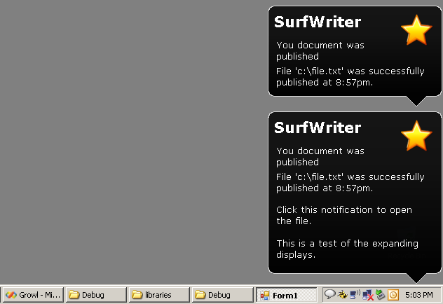

Animation Effects

The standard behavior of visual notifications is to simply appear on the screen when received and disappear immediately when closed. However, you may wish to animate one or both of these events. Examples include:

- Fading the notification window in and then out again
- Popping the notification up with a toast-like effect
- Sliding the notification in from an edge of the screen

To make animating your notifications more convenient, the NotificationWindow class provides an .Animator property. If set, the window’s appearing and disappearing will be animated using the behavior defined in the Animator. Out of the box, the display base library contains the following built-in animators:

- FadeAnimator – fades the notification in and out
- PopupAnimator – pops the notification up and back down (toast)
- Win32Animator – exposes the Win32 AnimateWindow API

Nothing more is required to enable these animation effects other than setting the .Animator property of your notification window to an instance of one of these animators.

this.Animator = new FadeAnimator(this);

If you want to animate your notification but do not want to use one of the built-in animators, you must keep in mind a few guidelines:

- The initial animation when displaying the notification should hook into the BeforeShown event of the window. BeforeShown is preferred because it is after Load and AfterLoad, which are recommended places to determine the form's intial size and position, both of which are probably necessary for animation. It is also after any LayoutManager repositioning, which is useful if your animation will be resizing the form into view (by ensuring there will be enough free space for the final form size).
- The closing animation should hook into the AutoClosing event. AutoClosing is preferred because it happens before FormClosing, allowing implementors the ability to control when the form is actually closed (usually after the animation completes). AutoClosing is also only fired when the notification has been ignored by the user, which is an appropriate time to animate the closing. If the form is actively closed by the user via click, the window should close immediately in most cases and skip any animation. If the notification is closed via keyboard shortcut (CloseAllOpenNotifications or CloseLastNotification), the window should be closed immediately in all cases and not animated away.
- You should honor the .Disabled property of the IAnimator class. If the animator has been disabled, do not perform any animation. (This property is automatically set if a call to CloseAllOpenNotification or CloseLastNotification is made.)

See the ‘Sample Visual Display’ project in the Growl Display SDK for a working example.

Display Settings

Growl allows the end user the ability to configure each display if it has any user-configurable settings, regardless of if it is a visual display or not. Examples may include:

- The colors of the text or background of the notification
- The location that the notification appears at
- Whether or not to play a sound when the notification is displayed
- The username or API key for posting notification data to an website

As the display developer, you decide which settings you would like to expose to the user, and via what interface they can be set. Growl then provides the mechanism to pull in your settings interface into its client.

If your display does not provide any user-configurable settings, you do not need to take any additional steps.

Settings Panel

If your display does expose user-configurable settings, you must create a SettingsPanel. Your SettingsPanel is just a special type of UserControl. To create a SettingsPanel, create a class and inherit from Growl.DisplayStyle.SettingsPanelBase:

public partial class SampleSettingsPanel : SettingsPanelBase

In your display class, you should set the .SettingsPanel property from within the default constructor:

public SampleDisplay()
{
this.SettingsPanel = new SampleSettingsPanel();
}

Since your settings panel is just a UserControl, you can pretty much do anything you would normally do in a UserControl, with the following restrictions:

- The BackColor should be set to Transparent. Growl will do this automatically when displaying your SettingsPanel, but it is a good idea to do it explicitly as well to ensure your control ends up looking how you intended.
- Any settings you want to save in the SettingsCollection must be of a serializable type (see Loading and Saving settings below)
- The Growl client will ensure that the settings panel is never resized smaller than 450*155 pixels. Your panel should be layed out to work at this size, as well as handle larger sizes (usually simply designing for 450*155 and setting .Anchor = Top | Left is preferred).

See the ‘Sample Display’ project in the Growl Display SDK for an example using a custom SettingsPanel.

Loading and Saving Display Settings

When a user uses your SettingsPanel to configure your display, you should make sure to remember their settings. The SettingsPanelBase class provides a SaveSetting() method that you should call whenever a user changes a setting. By default, the SettingsPanelBase class serializes the settings to disk in a file called ‘display.settings’ for each display for each user on a computer, but you may choose to override this behavior by setting the SettingProvider property to another ISettingProvider instance.

public SampleSettingsPanel()
{
this.SettingsProvider = new CustomSettingsProvider();
}

Even if you provide your own ISettingsProvider that does not serialize the settings, all setting values must be of a serializable type (see Important Notes below regarding passing values across AppDomain boundaries).

The GetSettings() method provides access to any saved settings. The settings are automatically read back in by the ISettingProvider when the display is first loaded.

Although the user modifies the settings via the SettingsPanel, the settings are also made available to the display class via the .SettingsCollection property. These settings can be queried when a notification is received and the display can act accordingly.

public override void HandleNotification(Notification notification, string displayName)
{
// read the filename from the settings
string filename = (string)this.SettingsCollection[SETTING_FILE_NAME];

// ...rest of handling code ...
}

Deploying Custom Displays

In order for Growl to use your custom display, it must know about it. Growl looks in the ‘Displays’ subfolder from its installation path for available displays. Each display should be in its own subfolder with all necessary files and assemblies required for its operation.

To deploy your custom display, you could simply have the user create a subfolder within the ‘Displays’ folder and copy your files into it. However, you may wish to create an installation routine that puts the files in the necessary location automatically. In order to determine where Growl is installed and where its ‘Displays’ folder is located, you can use the Growl.CoreLibrary.Detector class.

When an instance of the Detector is created, it automatically checks to see if Growl is installed on the machine. If it is not, the .IsAvailable property is set to false and all other properties return null. If Growl is installed, the Detector will report the location where Growl is installed, the location of the ‘Displays’ folder, the version, and other information about the Growl installation.

Detector detector = new Detector();
if (detector.IsAvailable)
{
Console.WriteLine(detector.InstallationFolder);
Console.WriteLine(detector.DisplaysFolder);
}

The detector only detects if Growl is installed, not if it is currently running. Growl does not need to be running in order for the Detector to work.

If you are using Visual Studio to create a Setup and Deployment Project, you can include a CustomInstaller module that creates the Detector and copies the files to the correct location. This approach ensures that the necessary display files get copied to the correct location and allows the user the ability to unintall the display using the standard Add/Remove Programs applet from the Control Panel.

See the ‘Display Installer’ and ‘Deployment’ projects in the Growl Display SDK for an example that uses a CustomInstaller to perform this action.

Important Notes

- When creating a visual display, be conscious of your notification window stealing focus form the foreground window. Many WinForms methods activate the form behind the scenes, including Move and Resize commands. Also, calling Screen.FromControl(form) will activate the form if Load has not been called yet. Other methods may also behave this way, so it is important to thoroughly test your display and to use the recommended events for various functions. (The base libraries will try to restore focus if it is stolen, but only after the necessary events are hooked up, which are normally after the Load event).
- Not all notifications that are passed to your display may contain images. Growl tries to use the default application icon for notifications that don’t specify an image, but there may be cases where an image is still not provided. Your display should handle the cases where no image is provided.
- All displays are loaded in a separate AppDomain than the main Growl client. This helps insulate the main application from display errors, but it also requires considerations when making calls across the AppDomain boundaries. Other than requiring that all settings are serializable, the base libraries try to handle all of the necessary marshalling, but there may be scenarios that are not supported.

